A000-EUR-Paleolithic-Figurine-Amber-Lithuania-15,000 BP

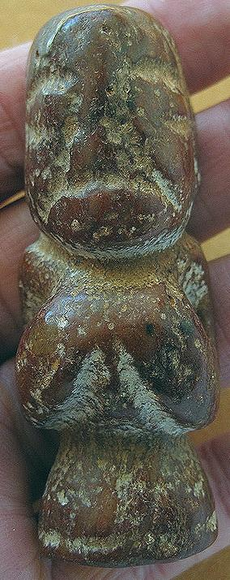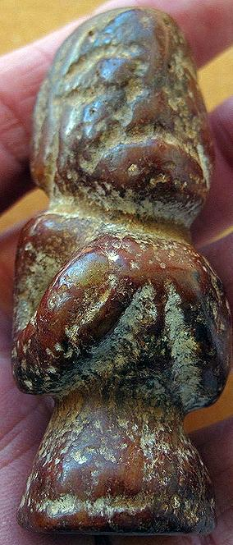 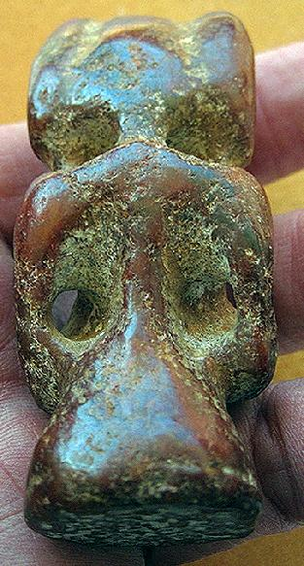

EUR-Paleolithic-Figurine-Amber-Lithuania-15,000 BP

**Case no.:** 1

Formal Label: EUR-Paleolithic-Figurine-Amber-Lithuania-15,000 BP

Accession Number:

**LC Classification:**

Date or Time Horizon: 15,000 BP

Geographical Area: Baltic Sea Coast, Lithuania

Cultural Affiliation: Baltic Paleolithic

Medium: amber

Dimensions:

Weight:

Condition:

Provenance: Baltic Sea Coast, Lithuania

**Discussion:**

**References:**